ISyE 4133: Advanced Optimization

Spring 2024

Mattieu Dahan

Supermarket Sweep

Team 8

Alexander Nathan, Dan That Ton, Qiming (Charlie) Wei, Priyali Bandla

**Table of Contents**

**Part A: Shortest Time Paths 1**

**Part B: MIP Formulation 2**

**Part D: Visualization 5**

**Part E: Sequential Model 6**

**MIP Formulation 6**

**Model Results Shopper 1 7**

**Shopper 2 Constraints 7**

**Model Results Shopper 2 9**

**Sequential Model Results 9**

# **Part A: Shortest Time Paths**

To set up the supermarket sweep problem, we need to first compute the time of walking between each item. With 56 distinct items, one starting location (treated like an item), and one ending location which is the same as the start location (treated like an item), we need to find the shortest paths of walking. For each pair i, j where i is item 0 to 56 and j is item 0 to 57, the Figure 1 represents the matrix of distance in seconds (full matrices can be found in the appendix). Figure 2 contains the fastest path from the start node to each item.

We calculated these values by comparing the x coordinate and y coordinate of the starting item i and arriving at item j. Our logic follows:

If the item is in the same x coordinate: $Shortest distance = |y_{1}-y_{2}|$

If the item is not in the same x coordinate:

$Shortest distance= min([+y_{2}, 220-y_{1}-y_{2})+|x_{1}+x_{2}|$

Shortest time = shortest distance/ speed(10)

Figure 1: Distance between items in seconds where Duration is in seconds

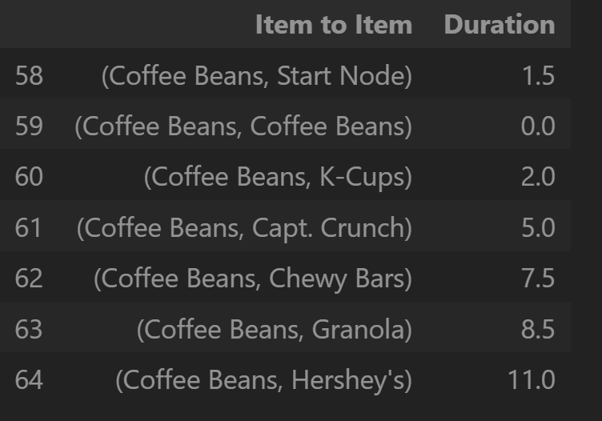

Figure 2: Fastest Paths from the Start node to each Item

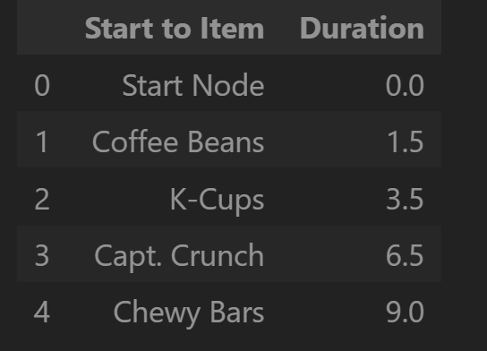

The two figures show the organization we used to structure the paths and item information to solve our models more easily.

# Part B: MIP Formulation

**Data**

End Node is added to the last row of the dataframe with the same attributes as Start Node.

**Parameters**

$c_{i}:price of item i where i = 0 to 56$

$c_{0} =0$

$d_{i,j}:shortest time from item i to item j where i = 0 to 56, j = 1 to 57$

$d_{i,i} =0$ for all i in [0, 56]

$d_{0,57} =0$

The distance from an item to itself is 0. The distance from the start node to the end node is 0 as they are the same physical location. The distance is calculated in seconds from Part A.

$y_{jk}:shortest time from start node to item i where j= 1 to 57, where k=1 to 2$

$y_{0k} = 0 for every k$

$y_{57k} = 0 for every k$

**Decision Variables**

$x_{i,j,k} = 1 if i,j is in tour of k, 0 otherwise where i =0 to 56, j = 1 to 57, k = 1, 2$

$x_{0,57,k}=0 for every k$

$x_{i,i,k}= 0 for every k$

The path from the start node to the end node directly is never taken for each shopper. The path from an item to itself is never taken.

$z_{ik} = 1 if item i is picked by k,where i = 0 to 56, where k= 1 to 2$

$z_{0k}=0$

$z_{57k}=0$

Items 0 and 57 which represent the start node and end node, treated like items, can never be chosen.

$t_{i,j,k} = y_{jk} if i,j in tour of k,0 otherwise, where i = 0 to 56$

$where j= 1 to 57, where k = 1 to 2$

**Objective Function**

$max \sum_{k = 1}^{2}{}\sum_{i=0}^{56}{}c_{i} z_{ik}$

We take the sum of items collected for each shopper and add the two values for the total value of items collected by the team.

**Constraints**

1. If $x_{ijk}=0$, then $t_{ijk}=0$
$t_{ijk}≤Mx_{ijk} for all i, j, k$

2. $y_{j }$ in terms of $t_{ijk}$
$y_{jk}=\sum_{i=0}^{56}{}t_{ijk}, for every j = 1 to 57, for every k = 1 to 2$

3. Shopper must reach end

$\sum_{i=0}^{56}{}x_{i57k}=1 for every k$

At least for one item, an item i to the last item (end node) must be true, this constraint ensures that each shopper returns to the start location.

1. Shopper must leave start

$\sum_{j=1}^{57}{}x_{0jk}=1 for every k$

At least for one item, the path from the start node to the first item take must be true, this constraint ensures that each shopper leaves the starting location.

1. 10 items maximum for each shopper

$\sum_{i=0}^{56}{}z_{ik}≤10 for every k$

$z_{0k}=0 for every k$

Each shopper can collect at most ten items, so the sum of items collected for each k must be less than or equal to 10.

1. An item can only be grabbed once
$\sum_{k=1}^{2}{}z_{ik}≤1 for every i =0 to 56$

2. Each shopper has 60 seconds
$\sum_{i=0}^{56}{}\sum_{j=1}^{57}{}d_{ij}*x_{ijk}+{2*\sum_{i=0}^{56}{}z_{ik}}_{}≤60 for every k = 1 to 2$

3. Constraints replacing TSP

If node is entered, then item in node is picked

If ${\sum_{i=0}^{56}{}x_{ijk}=1}_{} then {z_{jk}=1 }_{}$ for every j=1 to 56, k=1 to 2

$\sum_{i=0}^{56}{}x_{ijk}≤z_{jk}$

If node is not entered, then item in node is not picked

If ${\sum_{i=0}^{56}{}x_{ijk}=0}_{}for every j, for, then {z_{jk}=0}_{}$ for every j=1 to 56, k=1 to 2

$\sum_{i=0}^{56}{}x_{ijk} ≥ z_{jk}$

If leaving from node, then item in node is picked

If ${\sum_{j=1}^{57}{}x_{ijk}=1}_{}, then {z_{ik}=1}_{}$ for every i=1 to 56, k=1 to 2

$\sum_{j=1}^{57}{}x_{ijk}≤z_{ik}$

If not leaving from node, then item in node is not picked

If ${\sum_{j=1}^{57}{}x_{ijk}=0}_{}, then {z_{ik}=0}_{}$ for every i=1 to 56, k=1 to 2

$\sum_{j=1}^{57}{}x_{ijk}$ $≥ z_{ik}$

**Part C: Optimization Model**

Optimal Path for Shopper 1: (Start, 5) → (5,22) → (22,25) → (25, 26) → (26,30) → (30,35) → (35,38) → (38, 41) → (41, 42) → (42, 52) → (52, End)

Items Chosen for Shopper 1: ['Start Node', 'Ibuprofen', 'Diapers', 'Tampons', 'Shampoo', 'Trash Bags', 'Oreos', 'Popcorn', 'Gatorade (12)', 'Redbull (4)', 'Ritz', 'End Node']

Total Value for Shopper 1: $81.19

Optimal Path for Shopper 2: (Start, 1) → (1, 2) → (2, 26) → (26, 27) → (27, 31) → (31, 32) → (32, 33) → (33, 41) → (41, 42) → (42, 43) → (43, End)

Items Chosen for Shopper 2: ['Start Node', 'Coffee Beans', 'K-Cups', 'Toilet Paper', 'Paper Towels', 'Dish Soap', 'Detergent', 'Broom', 'Coca Cola (12)', 'LaCroix (12)', 'Pepsi (12)', 'End Node']

Total Value for Shopper 2: $83.39

Total Value: $164.60

# **Part D: Visualization**

The larger the time limit, the greater the total values of items collected. However with a time limit larger than 170 seconds, the total value tapers off. The relationship between time and total items collected value follows an approximately logarithmic relationship. With a time limit above 3 minutes (180 seconds) the maximum value of items is $183.50. With a time limit less than 8 seconds, the shoppers are unable to pick an item and return to the starting location. The smallest time of 8 seconds produces a total value of $10.98 between the two shoppers.

Figure 3: Graph of Time limit in seconds and maximum value of items collected in dollars

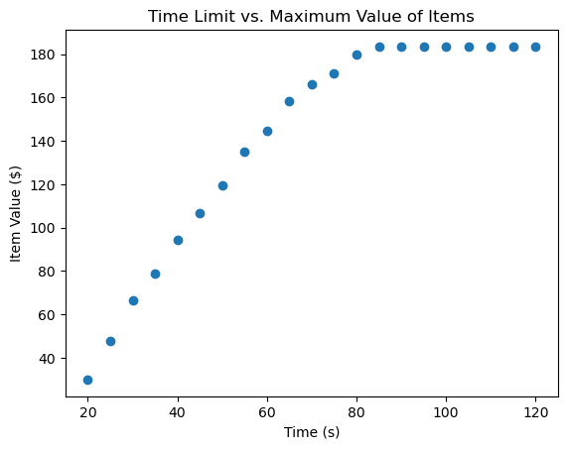

However, within the bounds of 8 seconds and 80 seconds the value of items collected and time allowed can be modeled as a linear function.

Figure 4: Total Value of Items based on time [8, 80]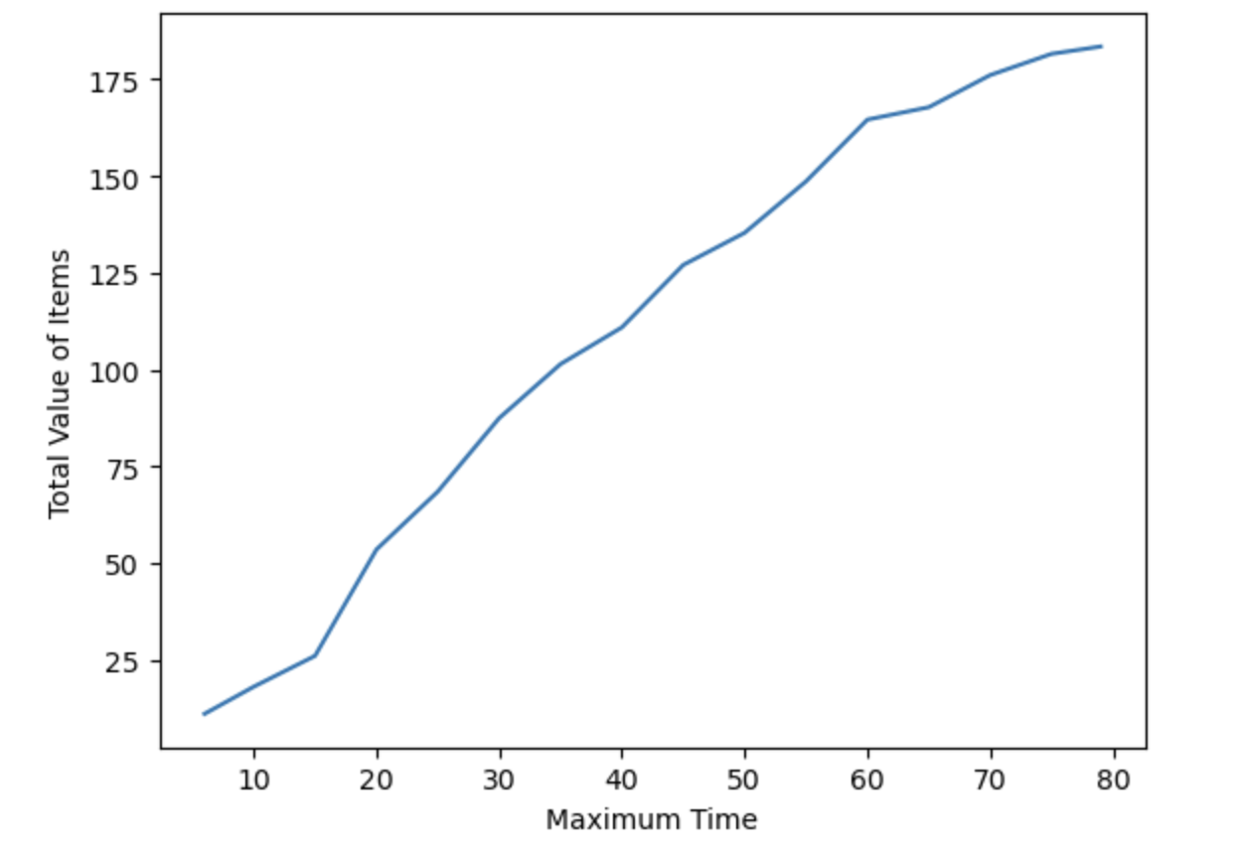

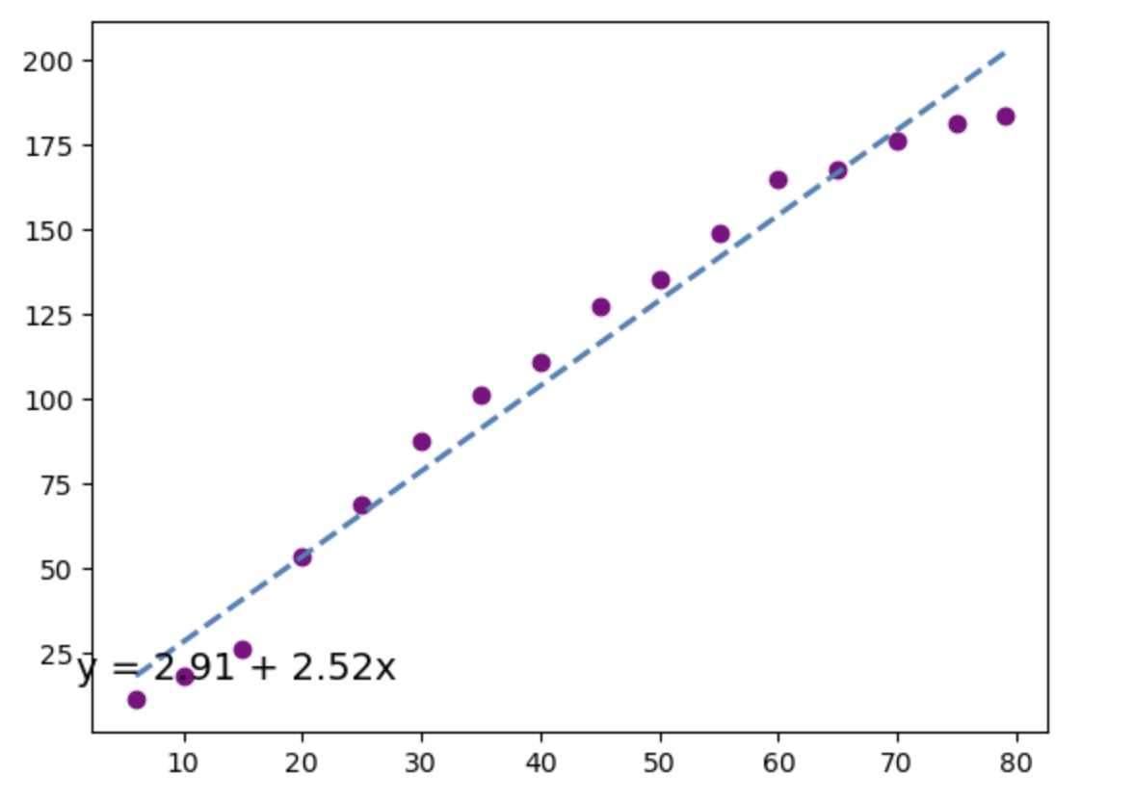

# **Part E: Sequential Model**

## **MIP Formulation**

Parameters:

$d_{ij}:shortest time to go from item i to item j, i =0 to 57, j =0 to 57$

$y_{i}: shortest time to go from start node/end node to item i, i = 0 to 57$

$c_{i}: price of item i = 0 to 57$

Decision Variables:

$x_{i,j} = 1 if i,j is in path of shopper 1,$

$0 otherwise, where i =0 to 56, j = 1 to 57$

$z_{i} = 1 if item i is picked by shopper 1$,

$0 otherwise,where i = 1 to 56$

Objective Function:

$max \sum_{i=1}^{56}{}c_{i} . z_{i}$

Constraints:

Cannot go from Start Node to End Node (They are the same node)

$x_{0,57} = 0$

Cannot go from Item Node i to Item Node i (They are the same node)

$x_{i,i} = 0, where i =1 to 56$

Cannot return to Item Node i already entered

$x_{i+1,i} = 0, where i =1 to 55$

Shopper 1 can grab a maximum of 10 items

$\sum_{i = 1}^{56}{}z_{i}≤10$

Shopper 1 has a maximum of 60 seconds to grab items

$\sum_{i=0}^{56}{}\sum_{j=1}^{57}{}d_{i,j}*x_{i,j}+{2*\sum_{i=1}^{56}{}z_{i}}_{}≤60$

Shopper 1 must leave the Start Node

$\sum_{j=1}^{56}{}x_{0,j}=1$

Shopper 1 must reach the End Node

$\sum_{i=1}^{56}{}x_{i,57}=1$

Item Node is entered if and only if Item is picked

$\sum_{i=0}^{56}{}x_{i,j}=z_{j} , where j = 1 to 57$

Item Node is left if and only if Item is picked

$\sum_{j=1}^{57}{}x_{i,j}=z_{i }, where i = 1 to 56$

## **Model Results Shopper 1**

Optimal Path: (Start, 1) → (1, 2) → (2, 10) → (10, 21) → (21, 22) → (22, 26) → (26, 27) → (27, 21) → (31, 32) → (32, 33) → (33, End)

Items Collected: ['Coffee Beans', 'K-Cups', 'Seasoning', 'Ibuprofen', 'Diapers', 'Toilet Paper', 'Paper Towels', 'Dish Soap', 'Detergent', 'Broom']

Total Value: $101.39

## **Shopper 2 Constraints**

For shopper 2 we used the exact same constraints as shopper 1 with one additional constraint excluding the set of items chosen by shopper 1. We created a new model in gurobi to solve the optimal path for shopper 2.

Parameters:

$d_{ij}:shortest time to go from item i to item j, i =0 to 57, j =0 to 57$

$y_{i}: shortest time to go from start node/end node to item i, i = 0 to 57$

$c_{i}: price of item i = 0 to 57$

Decision Variables:

$x_{i,j} = 1 if i,j is in path of shopper 2,$

$0 otherwise, where i =0 to 56, j = 1 to 57$

$z_{i} = 1 if item i is picked by shopper 2$,

$0 otherwise,where i = 1 to 56$

Objective Function:

$max \sum_{i=1}^{56}{}c_{i} . z_{i}$

Constraints:

Cannot go from Start Node to End Node (They are the same node)

$x_{0,57} = 0$

Cannot go from Item Node i to Item Node i (They are the same node)

$x_{i,i} = 0, where i =1 to 56$

Cannot return to Item Node i already entered

$x_{i+1,i} = 0, where i =1 to 55$

Shopper 2 can grab a maximum of 10 items

$\sum_{i = 1}^{56}{}z_{i}≤10$

Shopper 2 has a maximum of 60 seconds to grab items

$\sum_{i=0}^{56}{}\sum_{j=1}^{57}{}d_{i,j}*x_{i,j}+{2*\sum_{i=1}^{56}{}z_{i}}_{}≤60$

Shopper 2 must leave the Start Node

$\sum_{j=1}^{56}{}x_{0,j}=1$

Shopper 2 must reach the End Node

$\sum_{i=1}^{56}{}x_{i,57}=1$

Item Node is entered if and only if Item is picked

$\sum_{i=0}^{56}{}x_{i,j}=z_{j} , where j = 1 to 57$

Item Node is left if and only if Item is picked

$\sum_{j=1}^{57}{}x_{i,j}=z_{i }, where i = 1 to 56$

Item already picked by shopper 1 is not picked by shopper 2

$z_{i }= 0, where i = 1 to m$

$where items 1 to m are \{$ Coffee Beans, K-Cups, Seasoning, Ibuprofen, Diapers, Toilet Paper, Paper Towels, Dish Soap, Detergent, Broom $\}$

Simply, these items are no longer possible items to be chosen for shopper 2. The model is solved exactly the same as shopper 1 besides this.

## **Model Results Shopper 2**

Optimal Path: (Start, 3) → (3, 5) → (5, 23) → (23, 25) → (25, 30) → (30, 36) → (36, 38) → (38, 39) → (39, 40) → (40, End)

Items Collected: ['Start Node', 'Capt. Crunch', 'Granola', 'Toothpaste', 'Shampoo', 'Trash Bags', 'Oreos', 'Gatorade (12)', 'Redbull (4)', 'Ritz', 'End Node']

Total Value: $54.41

## **Sequential Model Results**

Total Value of both Shoppers: $155.81

Our very first model solved the paths for both shoppers simultaneously. Here, the total value of items are reached by solving the paths in series. First a model is created for shopper 1 and solved, then the item list is updated, a new model is created, and solved exactly the same way for shopper 2 with an updated item list.

The model that solved simultaneously for both shoppers had an objective value of $164.60 and the sequential model earned the team $155.81. Since the first method could “see” where the most valuable items were and could collect more highly-valued items apart from each other, since there are two shoppers, it performs better than a sequential model. This can be seen in many other real life situations like pooled queues, where the waiting items can go to either path, vs standard queues where items can only attend the corresponding station.

In the supermarket sweep problem, the difference between methods only differs by $8.79. However it is clear that the methodology and organization of formulation and solving optimization problems can make an impact on the end result, especially as the scale of the situation increases.